Computer Networks

## Assignment # 1

Name: M Zaeem Khalid

Class: BSCS 11C

CMS: 371303

# Question # 1

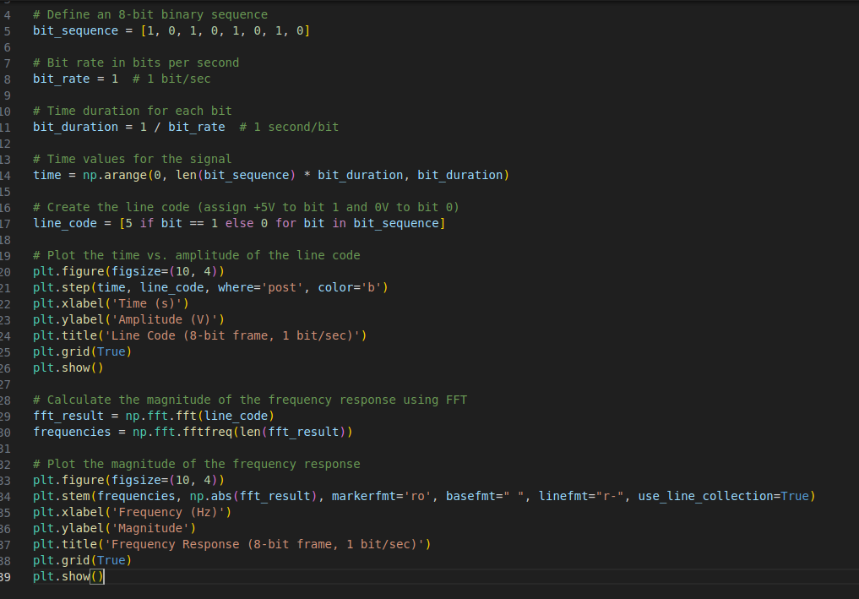

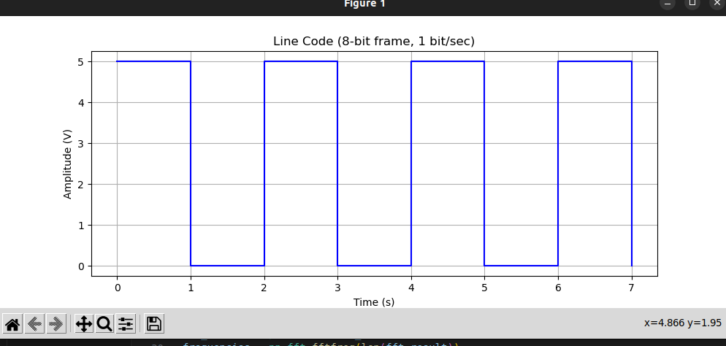

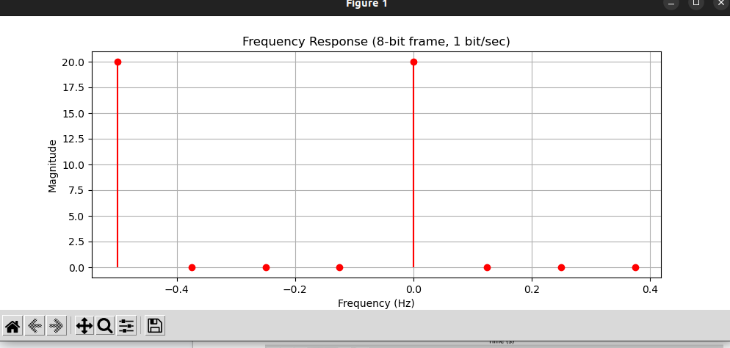

c)

If the frequency components above the 5th harmonic are suppressed, we can achieve this by keeping the first 6 harmonics and zeroing out the rest. To find the resulting time-domain signal, we need to perform an inverse Fourier Transform on this modified frequency spectrum and plot it. We will also compare it with the original signal.

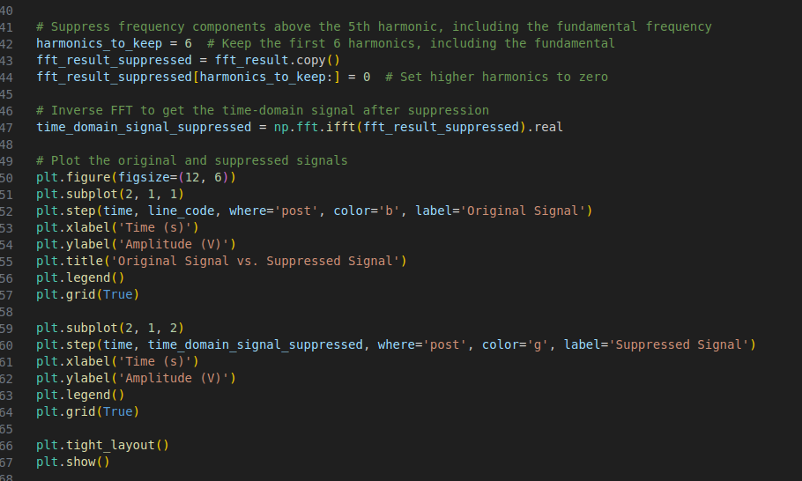

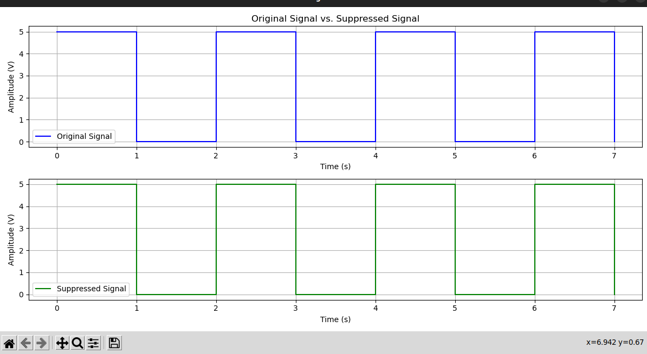

d) By using higher bitrate , the bandwidth increases. Using bitrate of 3 we get the following graph. Time interval decreases between each step in amplitude time graph

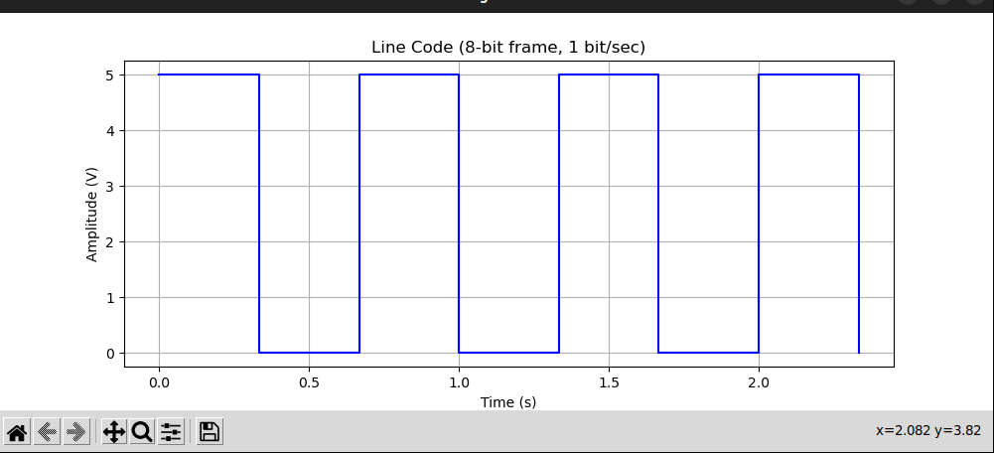

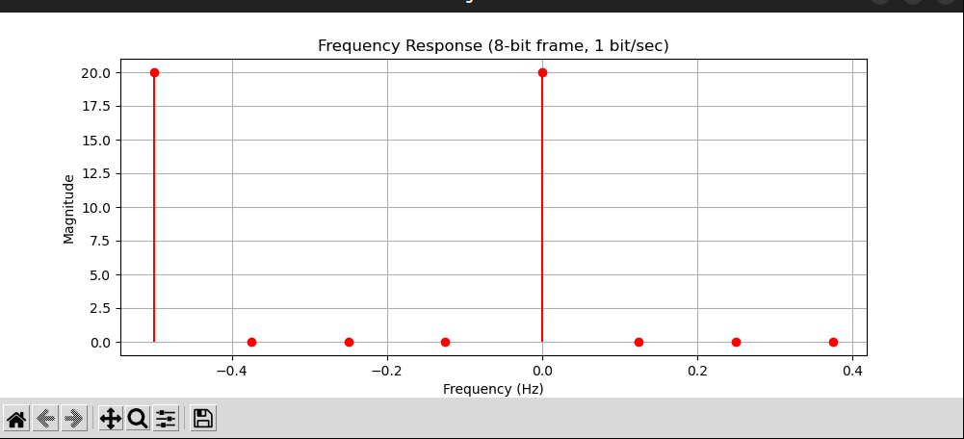

# Question # 2

a)

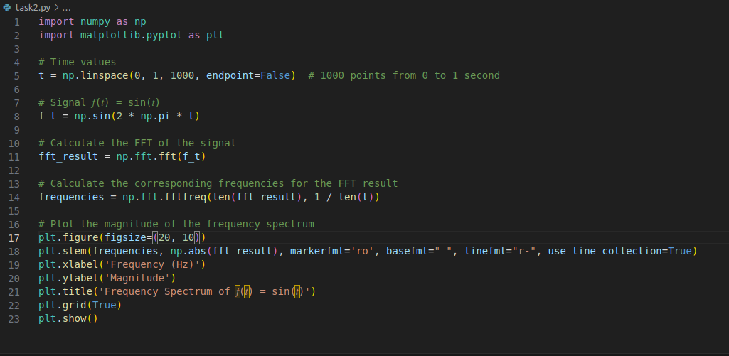

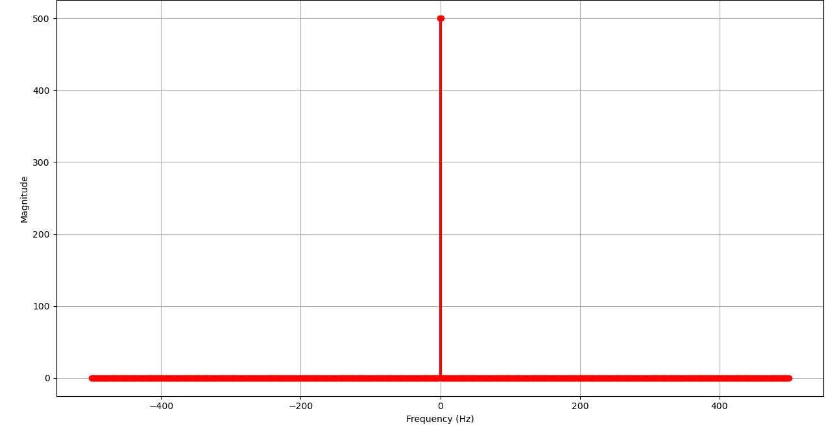

b)

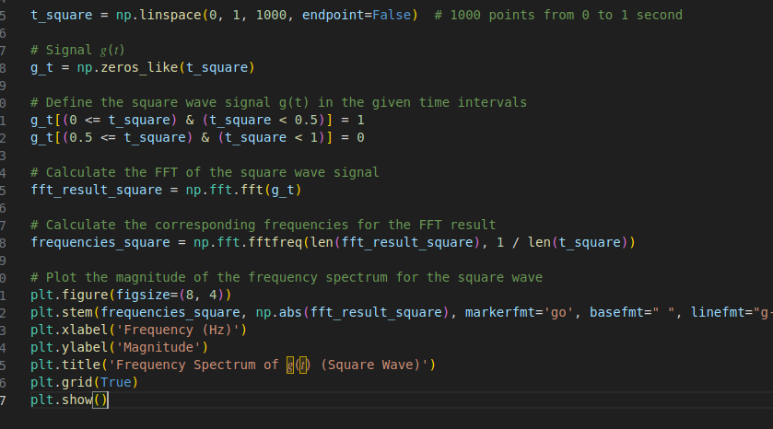

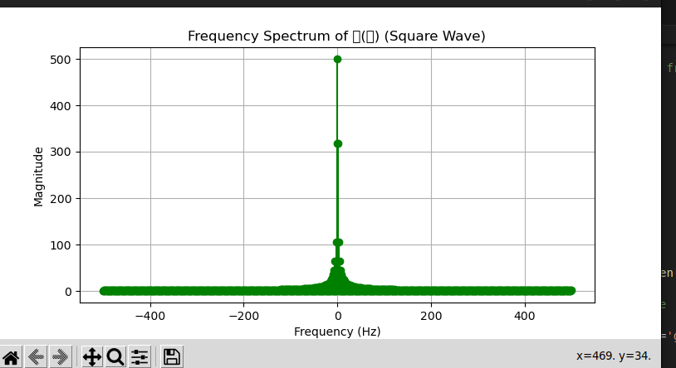

# Question # 3

# 

# 